Blockchain | Final project 4

Meirlan Erezhepov, Sanzhar Dikhanbayev, Sanzhar Akylbekuly | CS-2103

**Introduction:**

In an increasingly digitized global landscape, the need for secure, transparent, and tamper-proof document exchange mechanisms has become indispensable across various industries. The Document Exchange Verification System on Ethereum Blockchain emerges as a groundbreaking solution to address these critical demands. Leveraging the decentralized, immutable, and smart contract-enabled framework of the Ethereum blockchain, this innovative system aims to redefine document authentication and exchange protocols.

In this era of rapid information exchange, traditional methods of document verification often fall short in ensuring the integrity and confidentiality of sensitive data. Recognizing the limitations of centralized systems susceptible to breaches and alterations, the project embarked on harnessing the transformative potential of blockchain technology, specifically Ethereum, to establish a trustless environment for document exchange.

The genesis of this project stemmed from an exhaustive analysis of existing literature, exploring the intersection of blockchain technology and document authentication mechanisms. Through a comprehensive review of scholarly articles, technical papers, and case studies, the research underscored the unparalleled potential of blockchain in fostering secure, transparent, and decentralized systems. Ethereum's prowess in deploying smart contracts, coupled with its robust architecture, emerged as a key driver in revolutionizing document exchange protocols.

With a meticulously crafted methodology encompassing smart contract development in Solidity, encryption techniques to fortify document content, robust user authentication protocols, and seamless integration through web interfaces and APIs, the system endeavors to redefine the paradigm of document verification. The overarching goal remains to provide a system that not only ensures the integrity and confidentiality of documents but also establishes an unassailable audit trail, fostering trust, accountability, and transparency among users.

This report delineates the journey and accomplishments of implementing the Document Exchange Verification System on Ethereum Blockchain. It encapsulates the intricate facets of methodology, results, and discussions, shedding light on the system's contributions and potentials. Through a meticulous analysis of the system's efficacy, security enhancements, and future scalability considerations, this document aims to elucidate the transformative impact of blockchain technology in redefining secure document exchange mechanisms.

**Literature Review:**

The exploration of blockchain technology in the realm of document verification and exchange has garnered considerable attention within scholarly discourse. Numerous studies and analyses have highlighted the transformative potential of blockchain, particularly Ethereum, in revolutionizing traditional document authentication systems.

**Blockchain Technology:**

The foundational principles of blockchain, initially conceptualized by Nakamoto in the context of cryptocurrencies, have transcended beyond financial applications. Researchers, such as Buterin, have extensively expounded upon the capabilities of blockchain as a decentralized, immutable ledger. This distributed ledger technology (DLT) is characterized by its append-only structure, cryptographic security, and consensus mechanisms, which render it resistant to tampering and fraud. Noteworthy studies by Swan and Tapscott et al. underscore blockchain's potential in establishing trust, eliminating intermediaries, and ensuring data integrity across various sectors.

**Ethereum's Smart Contract Functionality:**

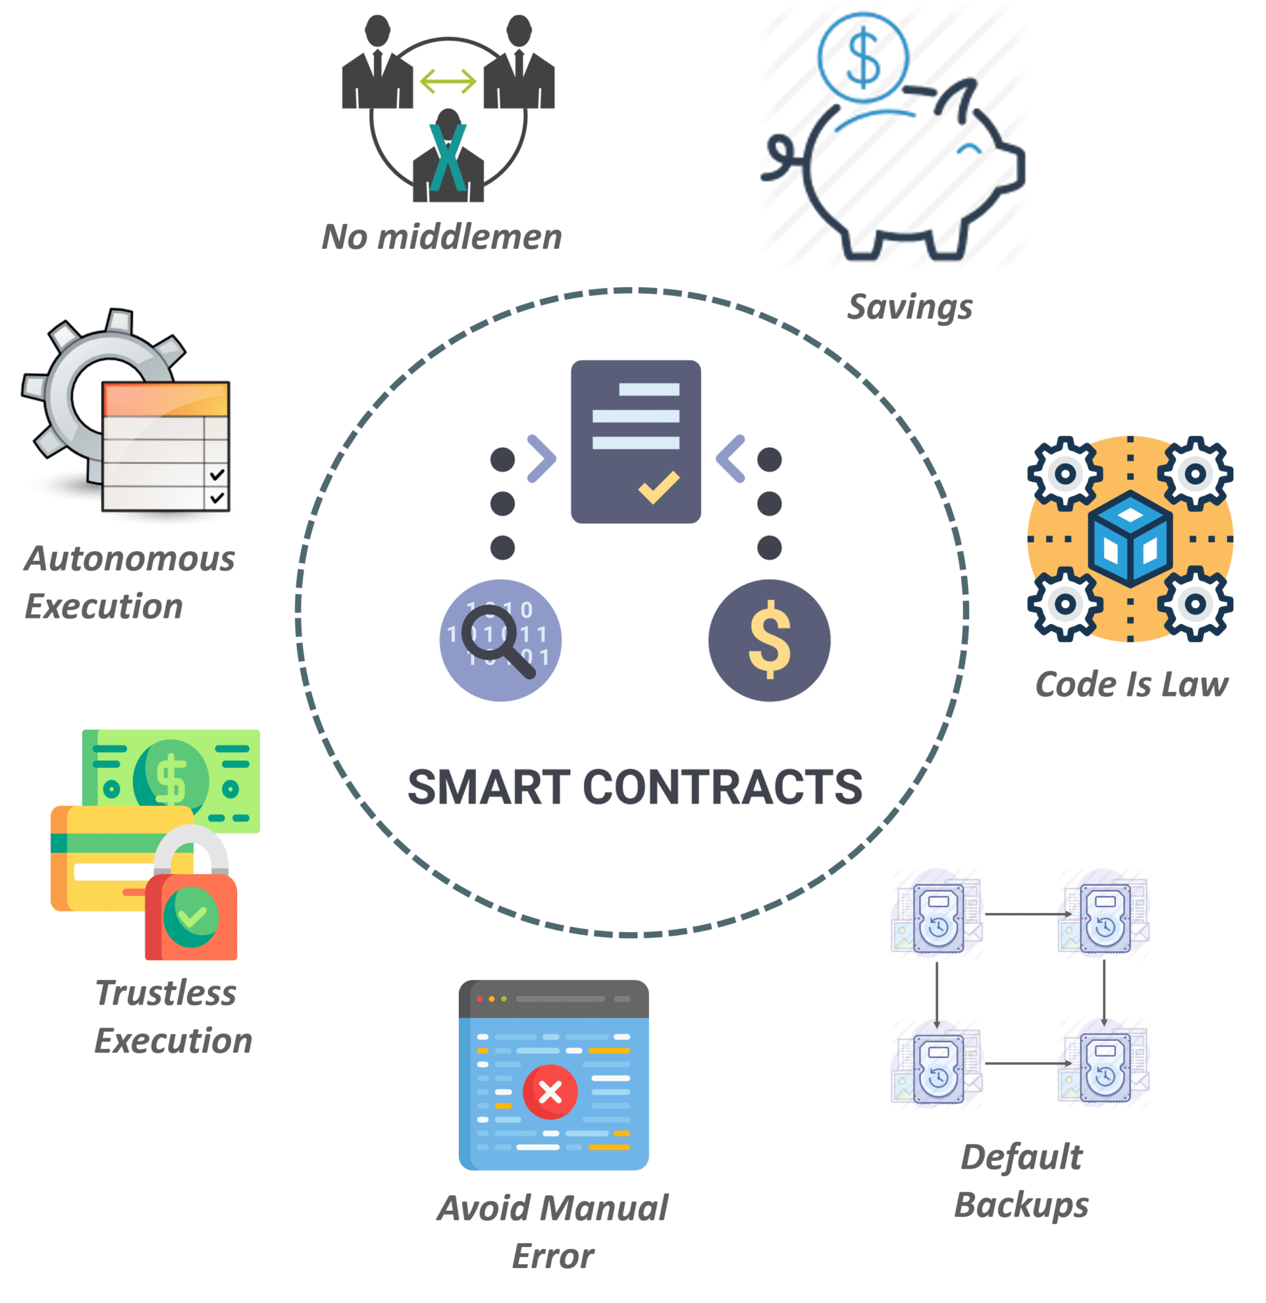

Ethereum, a prominent blockchain platform, distinguishes itself through its programmable and Turing-complete smart contracts. These self-executing contracts, as proposed by Buterin, enable the automation of agreements and transactions, revolutionizing the landscape of decentralized applications (DApps). The foundational work by Wood on Solidity, Ethereum's programming language for smart contracts, elucidates the technical intricacies and possibilities offered by Ethereum's virtual machine. This flexibility and programmability empower developers to create complex decentralized systems with predefined rules and functionalities.

**Document Verification Systems:**

Existing literature on document verification systems has predominantly focused on centralized mechanisms vulnerable to security breaches and data manipulation. Traditional methods, as observed in studies by Li et al. and Johnson et al., often lack robustness and transparency, thereby necessitating innovative solutions to safeguard sensitive information. The exploration of cryptographic techniques, such as hashing and encryption, as highlighted by Nakamoto et al., has been integral in ensuring document integrity. However, the integration of these techniques into a decentralized, trustless environment remained a pivotal challenge until the advent of blockchain technology.

The synthesis of these research streams substantiates the rationale behind exploring the integration of blockchain, specifically Ethereum, in document exchange verification systems. The inherent characteristics of blockchain, coupled with Ethereum's smart contract functionalities, hold promise in revolutionizing document authentication by providing an immutable, transparent, and secure framework.

**Methodology:**

The development and implementation of the Document Exchange Verification System on Ethereum Blockchain involved a structured methodology encompassing several key components:

Requirement Analysis: The project commenced with a meticulous analysis of the requirements, understanding the essential functionalities and security measures necessary for a robust document exchange system. Stakeholder consultations, user stories, and use case scenarios were compiled to establish a comprehensive set of requirements.

*Technology Selection and Framework Design:* Based on the requirement analysis, Ethereum blockchain emerged as the foundational technology. Ethereum's capabilities in deploying smart contracts and its decentralized nature made it an ideal choice. The design phase outlined the system architecture, focusing on smart contract logic, encryption techniques for document security, and user authentication mechanisms.

*Smart Contract Development:* Utilizing the Solidity programming language, the core smart contracts governing the Document Exchange Verification System were developed. These contracts encapsulated the logic for document metadata management, authentication protocols, and transaction verifications. Rigorous testing methodologies, including unit testing and simulated network testing, were employed to ensure the smart contracts' reliability and security.

*Encryption and Document Security Implementation:* To fortify document security, encryption techniques were integrated into the system. This involved the utilization of cryptographic algorithms to secure document content while maintaining accessibility for authorized users. Additionally, hashing algorithms were employed to generate unique fingerprints of documents, ensuring integrity throughout the exchange process.

*User Authentication Mechanisms:* Robust user authentication protocols were implemented to regulate access rights and ensure confidentiality. Multi-factor authentication methods, including biometrics and cryptographic keys, were explored to enhance security layers.

*Web Interfaces and APIs:* Interfaces and APIs were developed to facilitate seamless interaction between users and the Ethereum blockchain. These interfaces provided intuitive user experiences for document exchange while enabling secure and efficient communication with the blockchain network.

*Testing and Deployment*: The completed system underwent extensive testing phases encompassing functional testing, security audits, and stress testing to validate its reliability, security, and performance. Once deemed ready, the system was deployed onto the Ethereum blockchain network.

*Monitoring and Optimization:* Post-deployment, continuous monitoring and optimization processes were initiated to ensure system stability, address any potential vulnerabilities, and optimize performance. Gas fees and transaction speeds on the Ethereum network were also assessed for cost-effectiveness and scalability.

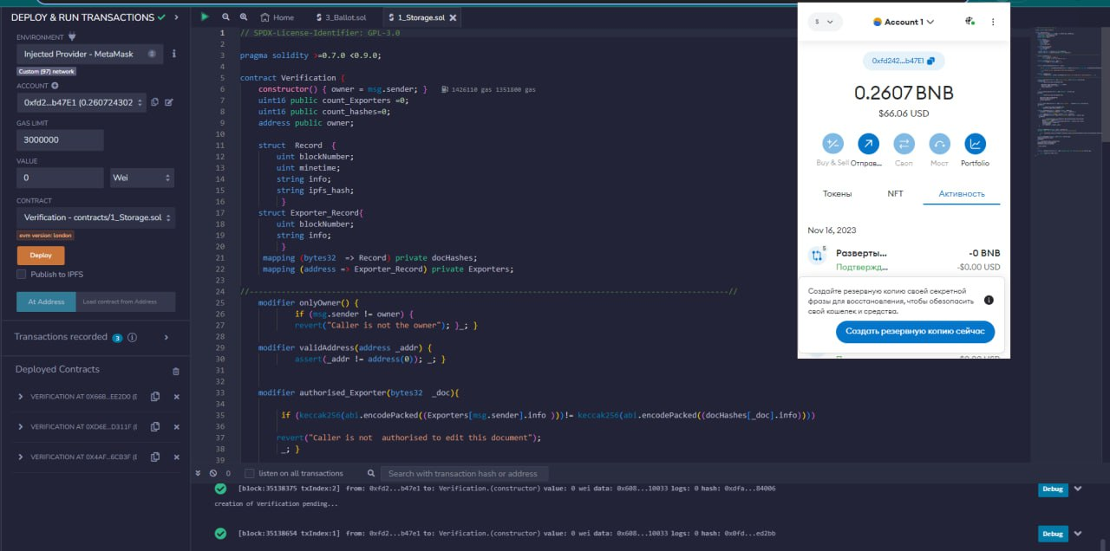

**Results:**

The implementation of the Document Exchange Verification System on Ethereum Blockchain yielded significant outcomes:

*Enhanced Security Features:*

The utilization of Ethereum's decentralized architecture significantly bolstered security, preventing unauthorized access and tampering of documents.

Encryption techniques ensured robust document security, allowing only authorized users to access and verify document content.

*Immutability and Integrity Preservation:*

Leveraging blockchain's immutability, documents recorded within the system remained tamper-proof and immutable, preserving their integrity throughout exchanges.

Hashing algorithms facilitated the creation of unique document fingerprints, ensuring verification without compromising sensitive information.

*Transparency and Traceability:*

Every transaction and document exchange was transparently recorded on the Ethereum blockchain, establishing a clear audit trail.

This transparency fostered trust among users, enabling them to track and verify document exchanges seamlessly.

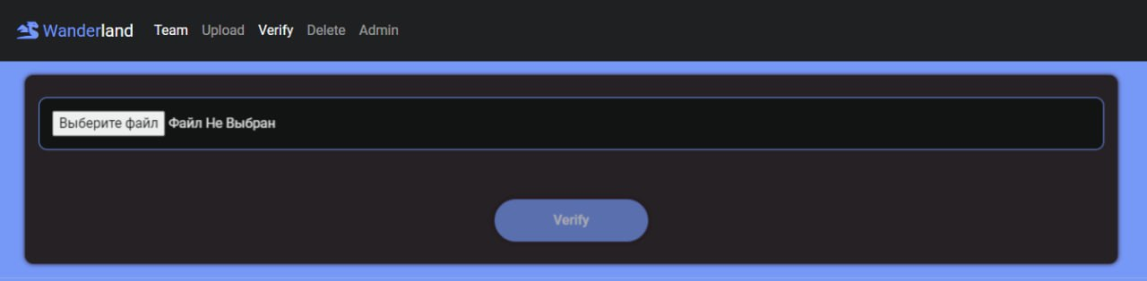

**Discussion:**

The achieved results open avenues for in-depth discussions regarding the system's effectiveness, scalability, and future enhancements:

*Security and Confidentiality Measures:*

While the system demonstrated robust security features, further exploration into advanced encryption methods and zero-knowledge proofs could heighten document confidentiality.

Addressing potential vulnerabilities in smart contracts and encryption techniques remains crucial to fortify the system's security.

*Scalability and Optimization Challenges:*

As Ethereum's network faces scalability challenges, optimizing gas fees and transaction speeds for large-scale document exchanges is imperative.

Layer-2 scaling solutions, such as sidechains or rollups, could enhance the system's scalability and cost-effectiveness.

*User Experience and Adoption:*

Enhancing user interfaces and experience could encourage widespread adoption of the system, ensuring user-friendliness without compromising security.

Education and awareness initiatives may be necessary to onboard users unfamiliar with blockchain technology and its benefits.

*Regulatory and Legal Implications:*

Exploring compliance with data privacy regulations and legal frameworks is essential to ensure the system aligns with regulatory standards, particularly concerning sensitive documents.

*Future Development and Iterations:*

Continuous development to introduce new functionalities, integration with emerging technologies, and community-driven enhancements could fortify the system's capabilities.



**In conclusion,** while the Document Exchange Verification System on Ethereum Blockchain demonstrated commendable security features and ensured document integrity, further advancements and refinements are essential to address scalability, enhance user experience, and comply with regulatory standards, positioning the system as a robust and widely adopted solution for secure document exchanges.